### **Branching workflow Diagram**

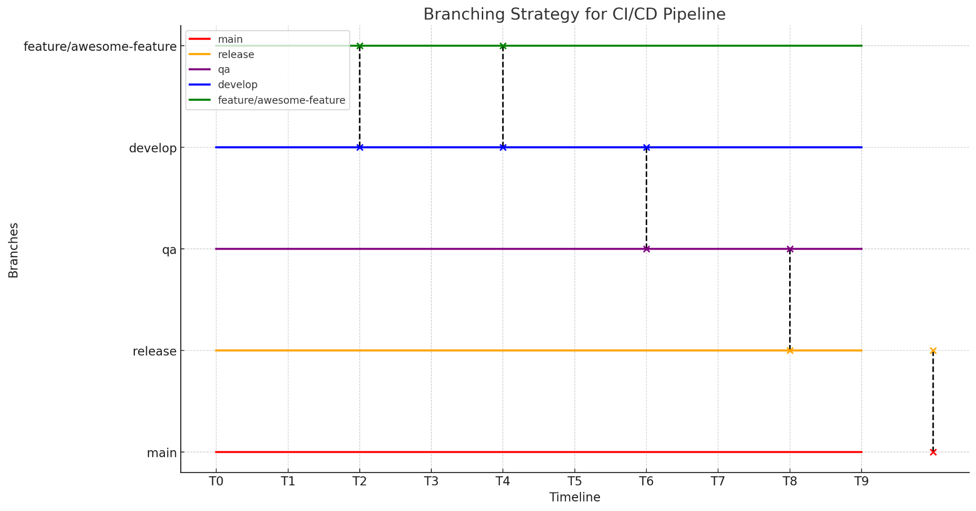

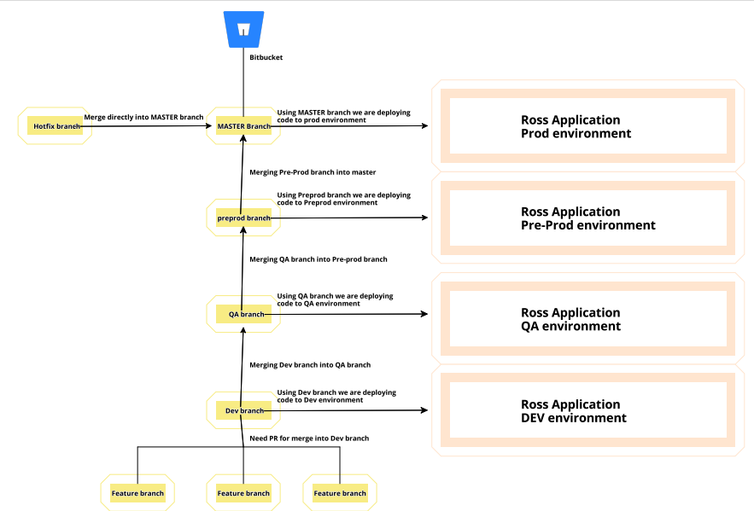

### 

### **-Branching Strategy**

1. **Main Branches:**
   * **main/master**: Represents the production-ready code. Only thoroughly tested and approved changes should be merged here.
   * **develop**: Represents the latest development changes. This is where developers merge their feature branches.
2. **Environment Branches:**
   * **release/pre-prod**: Used for preparing production releases. Code here is deployed to the pre-prod environment for final testing.
   * **qa**: Used for testing in the QA environment.
   * **dev**: Used for integration testing in the development environment.
3. **Supporting Branches:**
   * **feature/xxx**: Branches created for new features or improvements. These branch off from develop.
   * **bugfix/xxx**: Branches for fixing bugs found in the develop branch before a release. These branch off from develop.
   * **hotfix/xxx**: Branches for urgent fixes that need to go directly to production. These branch off from main/master.

### **Branching Workflow**

1. **Feature Development:**
   * Create a feature branch from develop: feature/feature-name.
   * Once the feature is complete, create a pull request (PR) to merge back into develop.
   * Automated tests and code reviews should be mandatory before merging.
2. **Development Deployment:**
   * When code is merged into develop, an automated build and deployment to the dev environment should trigger.
   * Perform integration testing in the dev environment.
3. **QA Testing:**
   * Once the integration testing in the dev environment is successful, merge develop into qa.
   * Automated build and deployment to the qa environment should trigger.
   * Perform comprehensive testing in the qa environment.
4. **Pre-Production Staging:**
   * After successful testing in the qa environment, create a release/pre-prod branch from qa:
   * Deploy the release/pre-prod branch to the pre-prod environment for final validation.
   * Perform final checks and acceptance testing in the pre-prod environment.
5. **Production Release:**
   * Once the pre-prod is approved in the pre-prod environment, merge the release/pre-prod branch into main/master.
   * Deploy to the prod environment.
   * Tag the pre-prod in the main/master branch for reference.
6. **Hotfixes:**
   * For urgent fixes, create a hotfix branch from main/master.
   * Apply the fix and test in a dedicated environment.
   * Merge the hotfix branch back into main/master and develop to ensure the fix is included in both the current production code and ongoing development.